Sunday, February 11, 2018

Unsolved murder in Jim Crow South

Anthony Grooms’ ‘The Vain Conversation’ imagines the story behind lynching in Georgia
LIVING

By Anjali Enjeti
0
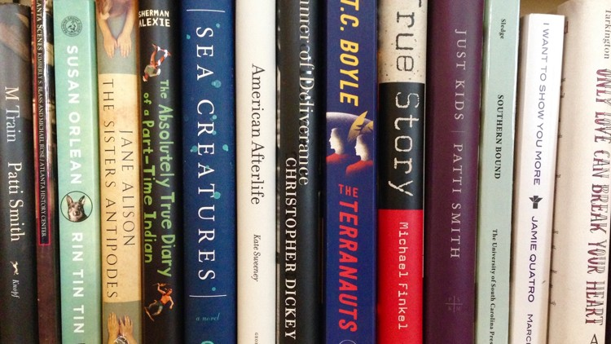The AJC bookshelf
Posted: 12:00 a.m. Saturday, February 10, 2018

On July 25, 1946, a wealthy white landowner named Loy Harrison was driving through Walton County with two African-American couples — Roger Malcolm and his wife Dorothy Malcolm, and George W. Dorsey, a World War II veteran, and his pregnant wife Mae Murray Dorsey. Fifteen to 20 white men forcefully removed the Malcolms and the Dorseys from Harrison’s vehicle near Moore’s Ford Bridge. Some 60 shots were fired at them in a field at close range and Mae Murray Dorsey’s fetus was cut out of her body. Despite an FBI reward of $12,500 for information leading to the capture of the murderers, no arrests were ever made.
Anthony Grooms’ stirring second novel, “The Vain Conversation,” pens a fictionalized account of this gruesome lynching in the aftermath of World War II. Grooms, director of the Masters of Professional Writing program at Kennesaw State University, has tackled the violence of the Jim Crow South alongside the traumas of war before. His 2002 debut novel “Bombingham” recalled the civil rights movement in light of the experiences of black soldiers serving in the Vietnam War.
In “The Vain Conversation,” Wayne Henson, a white sharecropper turned infantryman returns to his rural hometown of Bethany in Talmaedge County, after three years fighting abroad. Though grateful to be reunited with his wife Aileen, who works at an airplane plant in Marietta, and his young son, Lonnie, Wayne suffers from post-traumatic stress disorder, and is haunted, in particular, by one deadly decision he made during the war. Guilt and regret weigh heavily upon him until he confesses his shame to Bertrand Johnson, a black former teacher and corporal in the army who outranked Wayne. The two become fast friends and confidants, and eventually, Bertrand assists Wayne with filling out an application for trade school so Wayne can leave sharecropping for good.
+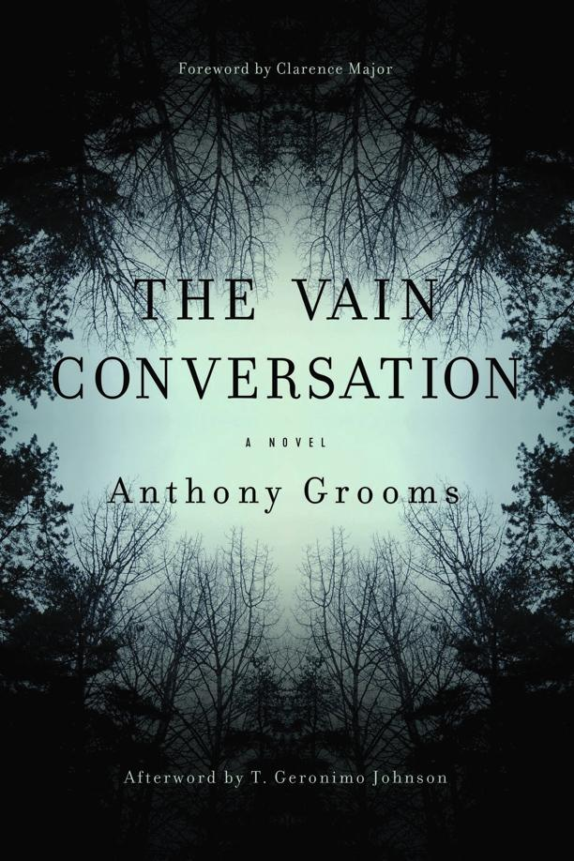
‘The Vain Conversation’ by Anthony Grooms
Like Wayne, Bertrand is also haunted by the war. He’s plagued with nightmares of liberating Buchenwald, the death camp near Weimar, Germany. “He focused on a young man, one nearly starved to death. The man’s head was stubbed from a recent shave. His face was gaunt and eyes sunken. Scabs and scars covered his face, and his skeletal hands, webbed by scabs, reached out to Bertrand.”
While serving abroad, Bertrand is aghast to find that the South’s segregation spans the width of the Atlantic Ocean. “Even the German POWs had privileges denied to the colored soldiers. The Nazis played volleyball while the colored soldiers washed their clothes and cleaned up after them. This is how much you matter in America, he had thought. So little, so nothing, that a mortal enemy gets treated better than colored.”
But Bertrand’s burgeoning friendship with Wayne, and Wayne’s outspoken belief in equality, leaves Bertrand optimistic about the future of race relations in Bethany. “The war had changed things. Or had it? He wanted to believe it had.”
Bertrand’s wife Luellen, a survivor of the 1923 massacre on her hometown of Rosewood, Florida, tries mightily to disabuse her husband of his faith in good white people and his dream of a South free from Jim Crow. “Think, Bertrand. Don’t forget where you are, husband. You are not in Paris, France, or even New York City.” Milledge, Bertrand’s mother, takes Luellen’s side. Despite working for a white farmer named Noland Jacks for decades, who on the surface appears to be kind to members of the black community, Milledge remains distrustful of the white people of Talmaedge County.
Meanwhile Aileen condemns her husband Wayne’s relationship with Bertrand and warns Lonnie about his father’s poor judgment. “I met colored people, too, over at the factory and I’d bring them home too, if there was a cause. But to sit [Bertrand] up in the front room and to tell me to make coffee.” After Wayne disappears, Bertrand helps Aileen with her garden and other chores, and takes young Lonnie under his wing. Rumors circulate throughout their community that Aileen and Bertrand are more than mere acquaintances, and soon thereafter an incident of sexual harassment involving a brutish landowner named Vernon Venable and Bertrand’s cousin Beah sets off a chain of events that leads to the lynching.
+
Author Anthony Grooms
The landscape of rural Georgia — the tangle of blackberry and kudzu vines, the “yellow sweet gum, russet oaks and the occasional flame-red map” — serves as a trenchant backdrop to the brutal murders. Grooms tell this riveting story from three points of view, that of Lonnie, Bertrand, and Jacks, Milledge’s employer. The lynching itself occurs within the first few pages, but Grooms then rewinds time to Wayne and Bertrand’s return from the war. With each scene, Grooms fastidiously builds tension and suspense and patiently plants the seeds for well-meaning white characters’ betrayal and complicity. Aileen uses her Christianity to justify her refusal to come to the defense of Bertrand and his family. Venable twists and manipulates Lonnie’s innocent remarks, and Jacks deliberately ignores signs of the inevitable. In Grooms’ skillful hands, seemingly inconsequential actions and decisions snowball, in a matter of a few days, into a savage mob mentality.
Despite firsthand experience with the daily terrorism of segregation in the U.S. and the ravages of the Holocaust in Europe, Bertrand holds tight to his belief that there are degrees of hatred — a belief he will come to lament. “There are plenty of fascists in America, he thought. Plenty who would do just this kind of thing. But America ain’t this bad.”

FICTION
‘The Vain Conversation’
By Anthony Grooms
Story River Books
256 pages, $27.99
http://www.myajc.com/entertainment/books--literature/unsolved-murder-jim-crow-south/75Eoi7NrjZWva5dnDhhDnM/

